1. select ename,job,deptno from emp where job=’CLERK’

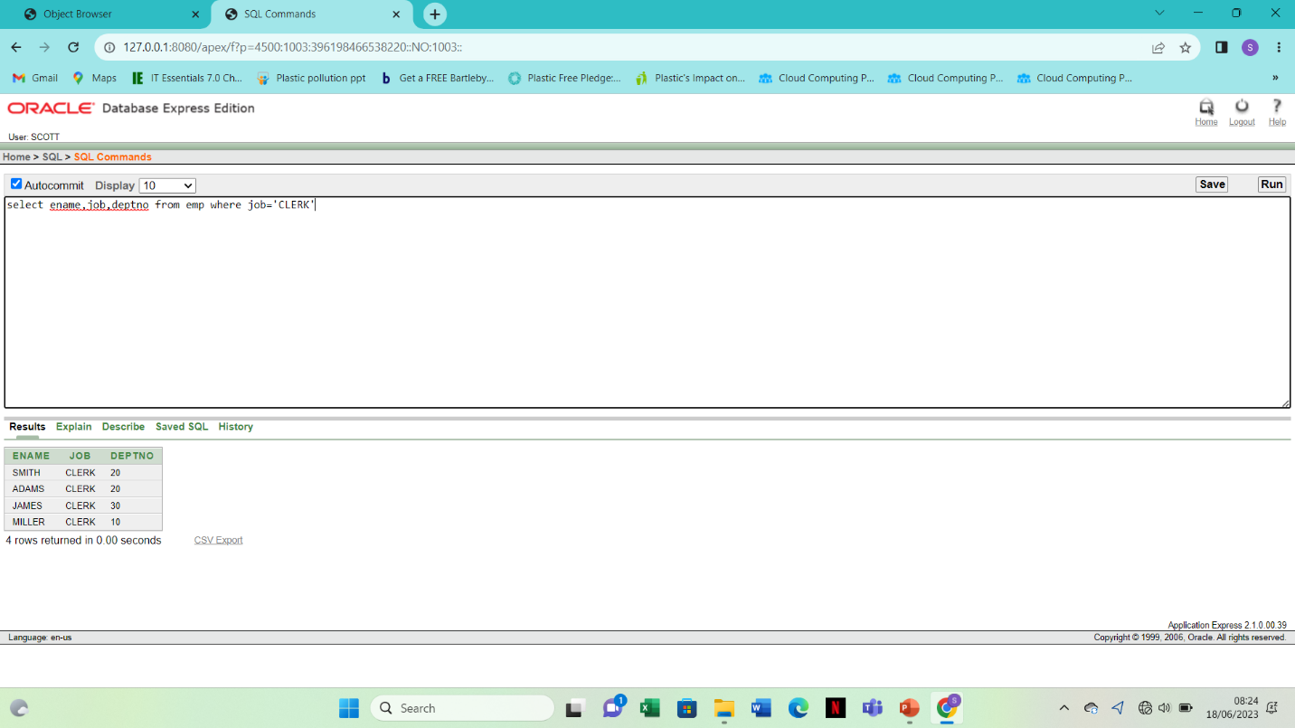2. Select ename ,job,deptno from emp where ename=’JAMES’

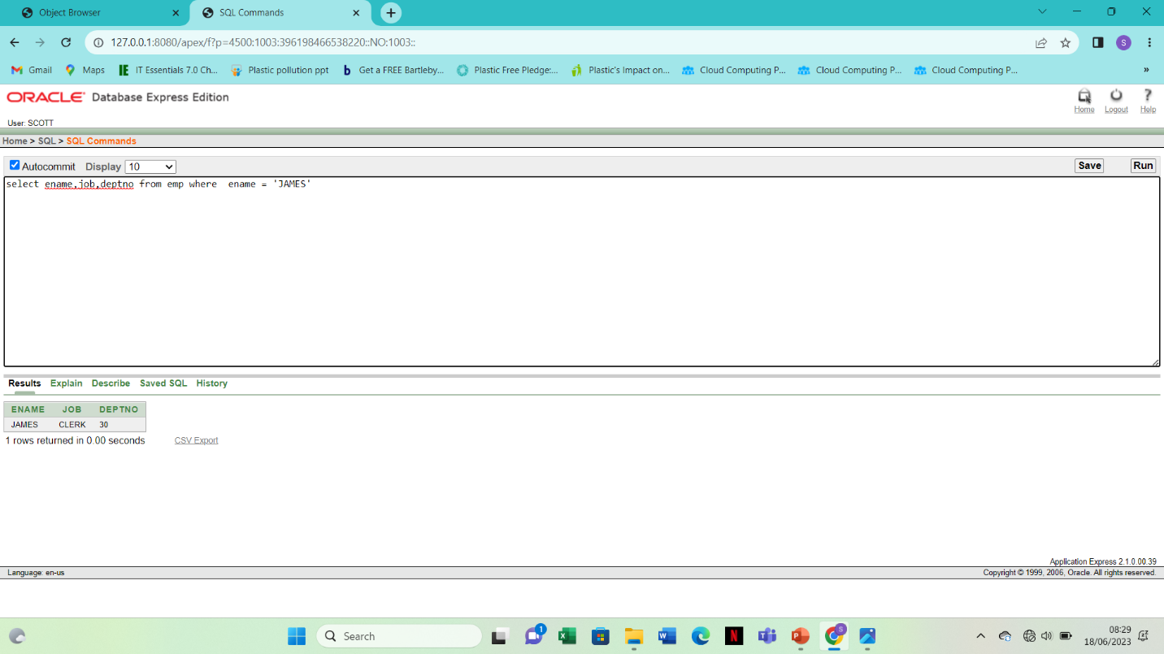3. Select ename,sal,comm from emp where sal<=comm

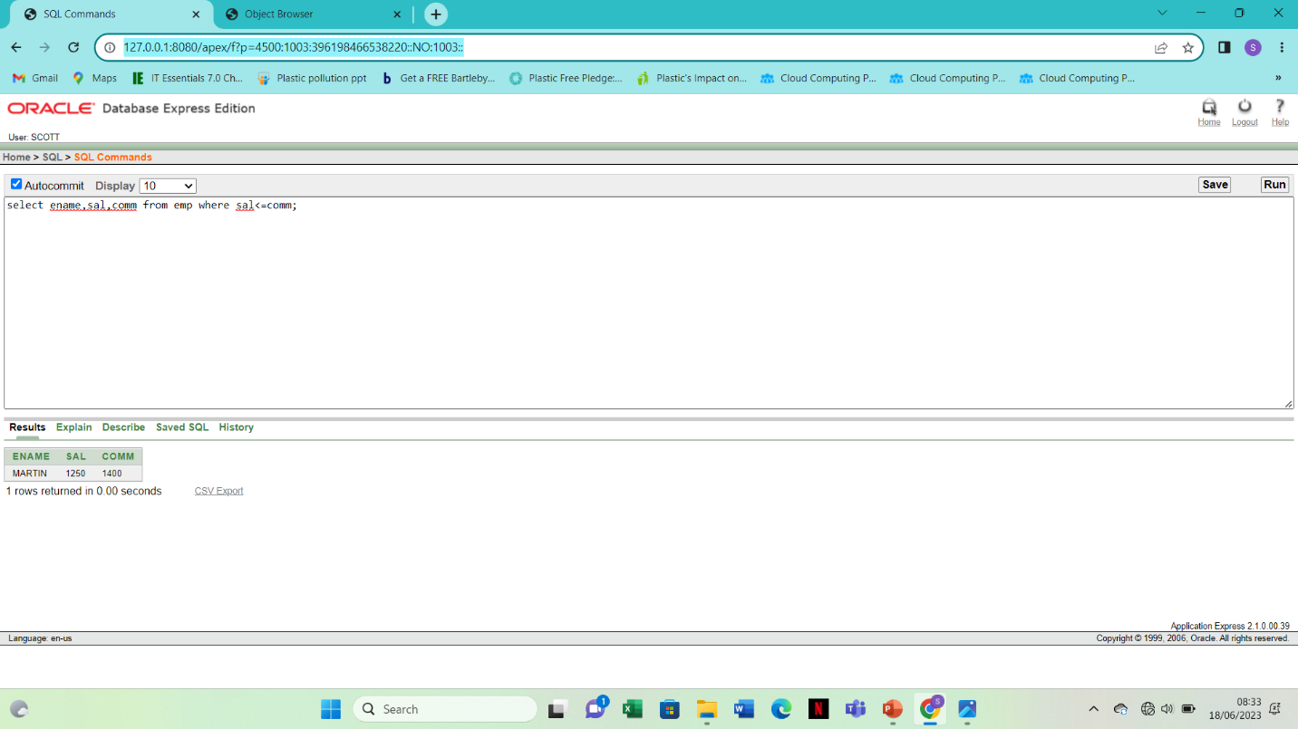

4. select ename,sal from emp where sal between 1000 and 1500

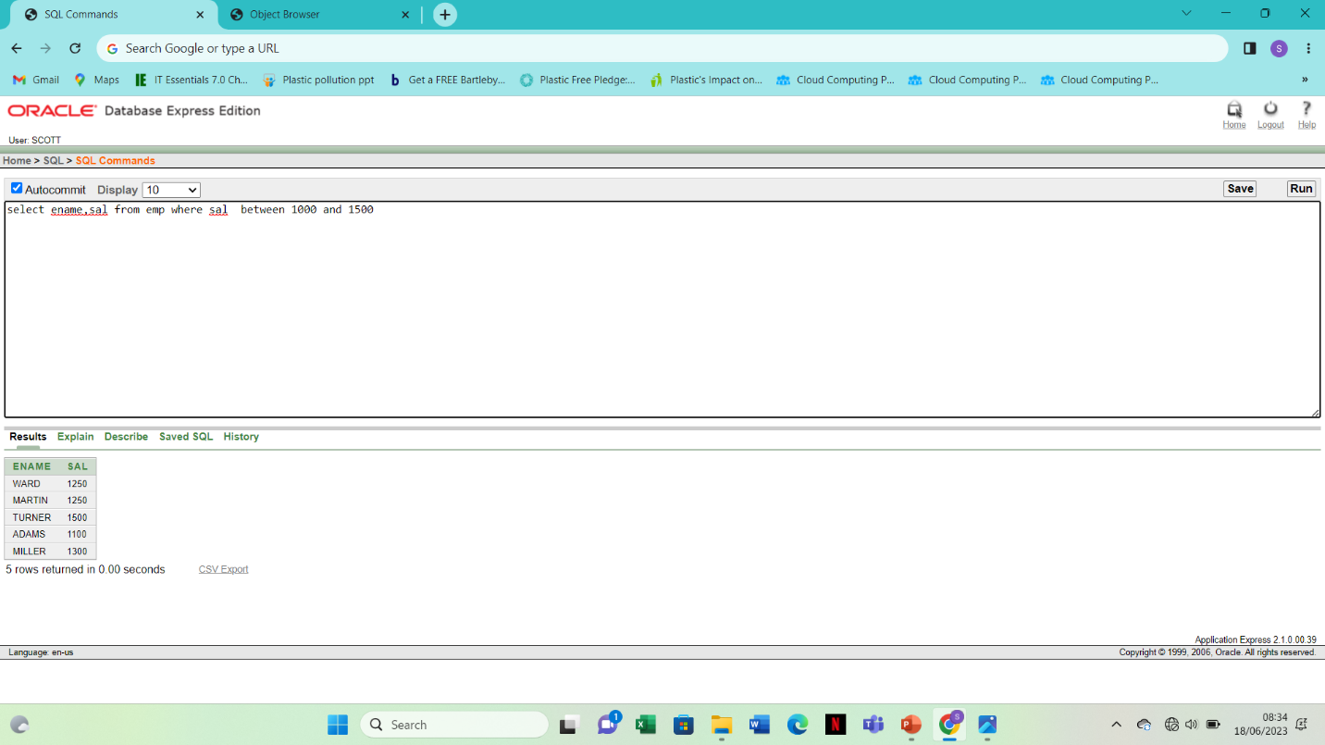

5.select empno,ename,sal,mgr from emp where mrf in (7902,7566,7788)

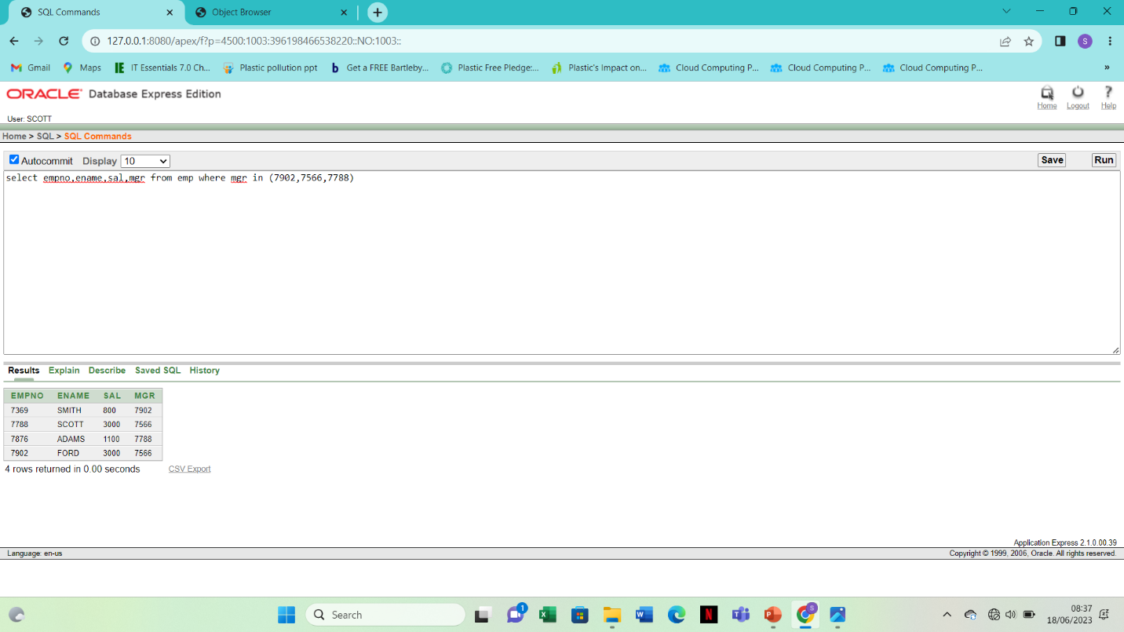

6. select ename from emp where ename like ’_A%’

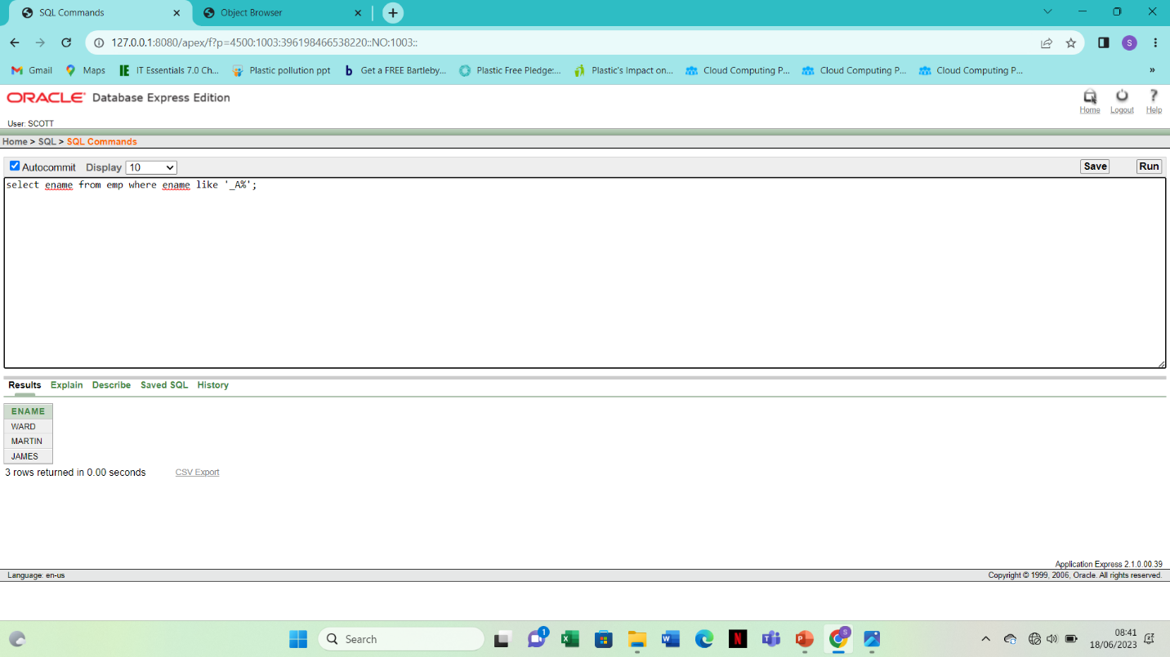

7. select ename,mgr from emp where mgr is NULL

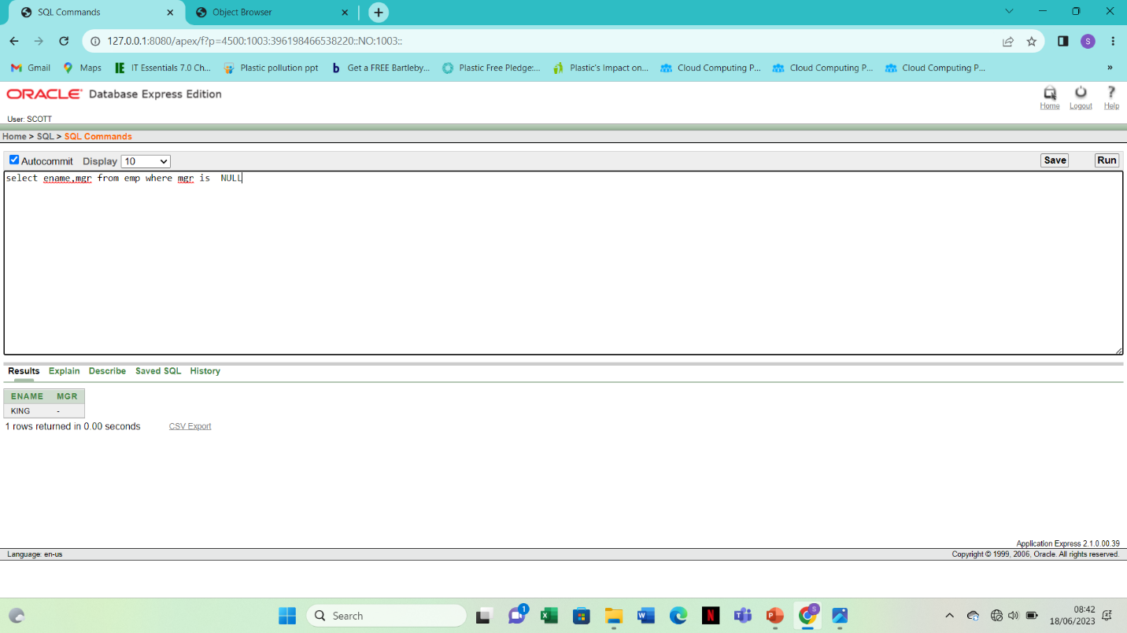8.select empno,job,sal from emp where sal>=1100 and job = ‘CLERK’

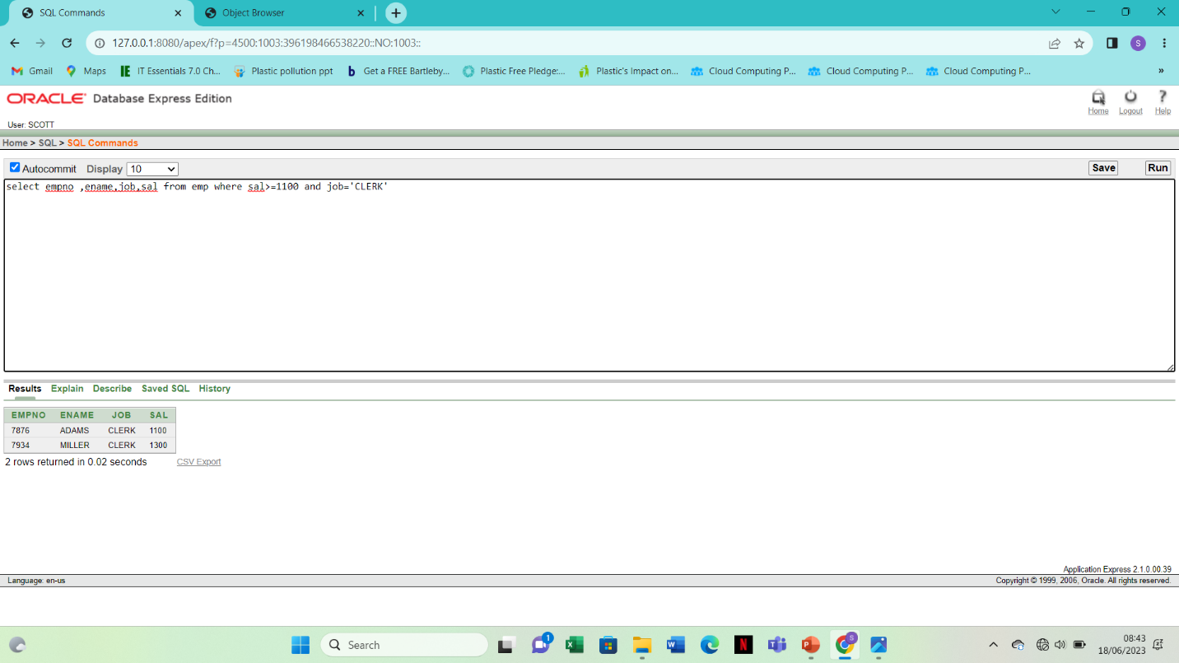9. Select ename ,job from emp where job not in (‘CLERK’,’MANAGER’,’ANALYST’)

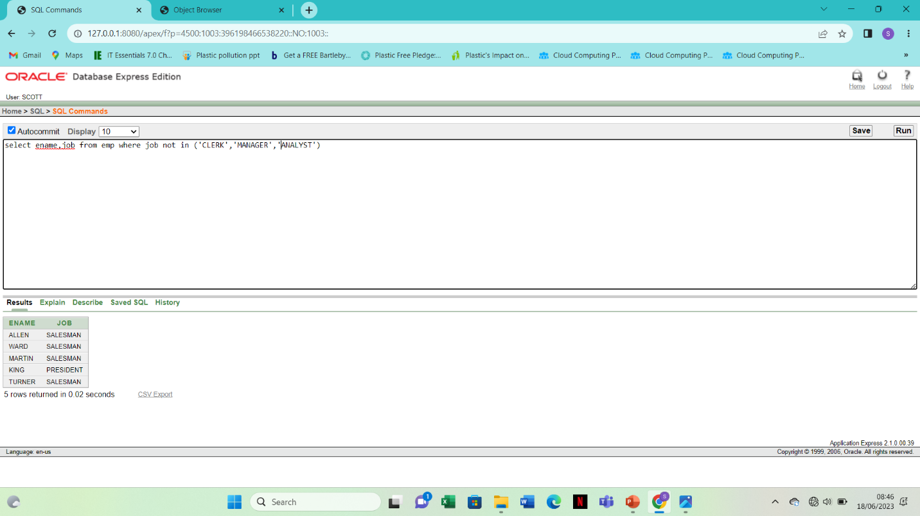

10. select ename , job,sal from emp where (job=’SALESMAN’OR job=’PRESIDENT’)AND sal>1500

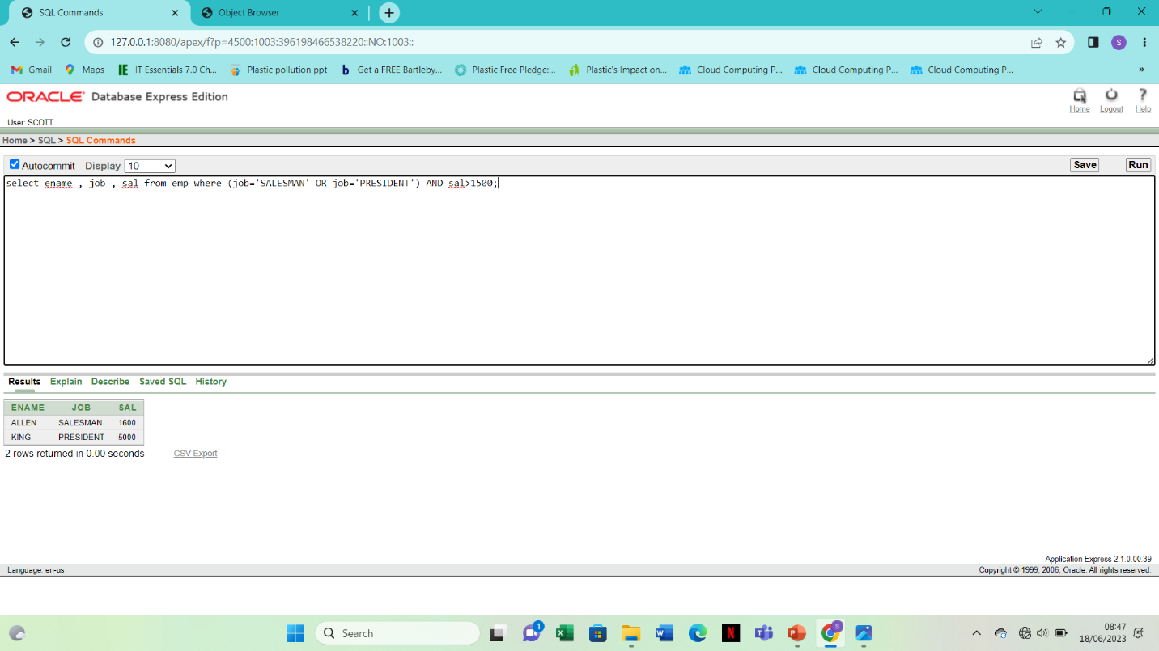

11.select ename,job,sal from emp where job =’SALESMAN’ or job=’PRESIDENT’ and sal>1500

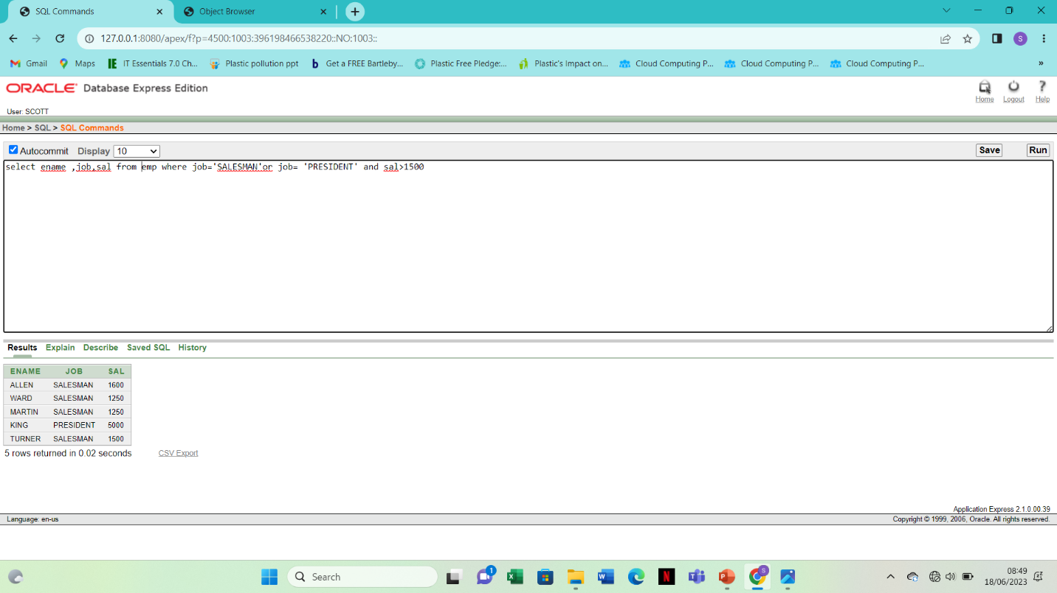

12.select ename,job,deptno,hiredate from emp order by hiredate

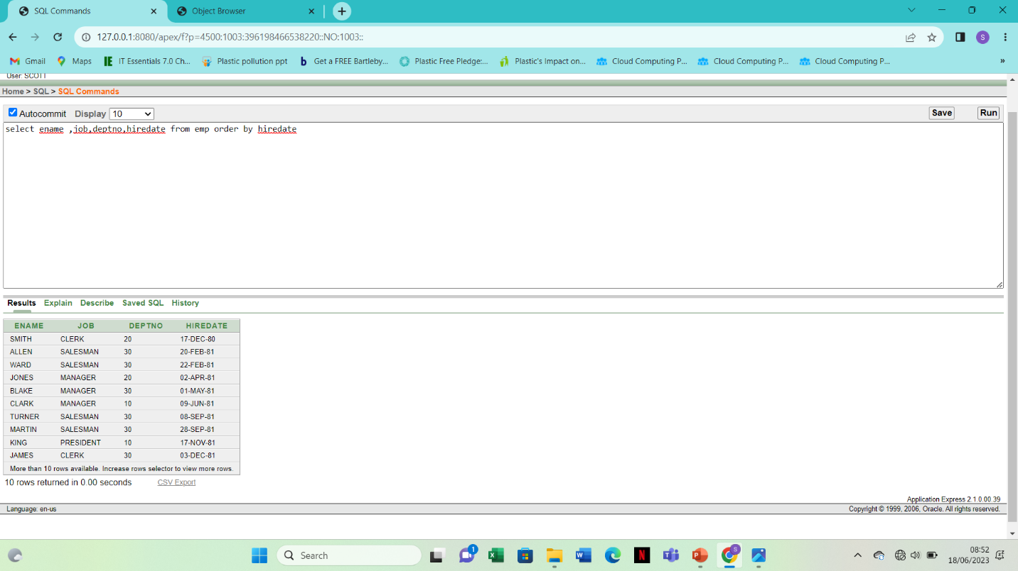

13.

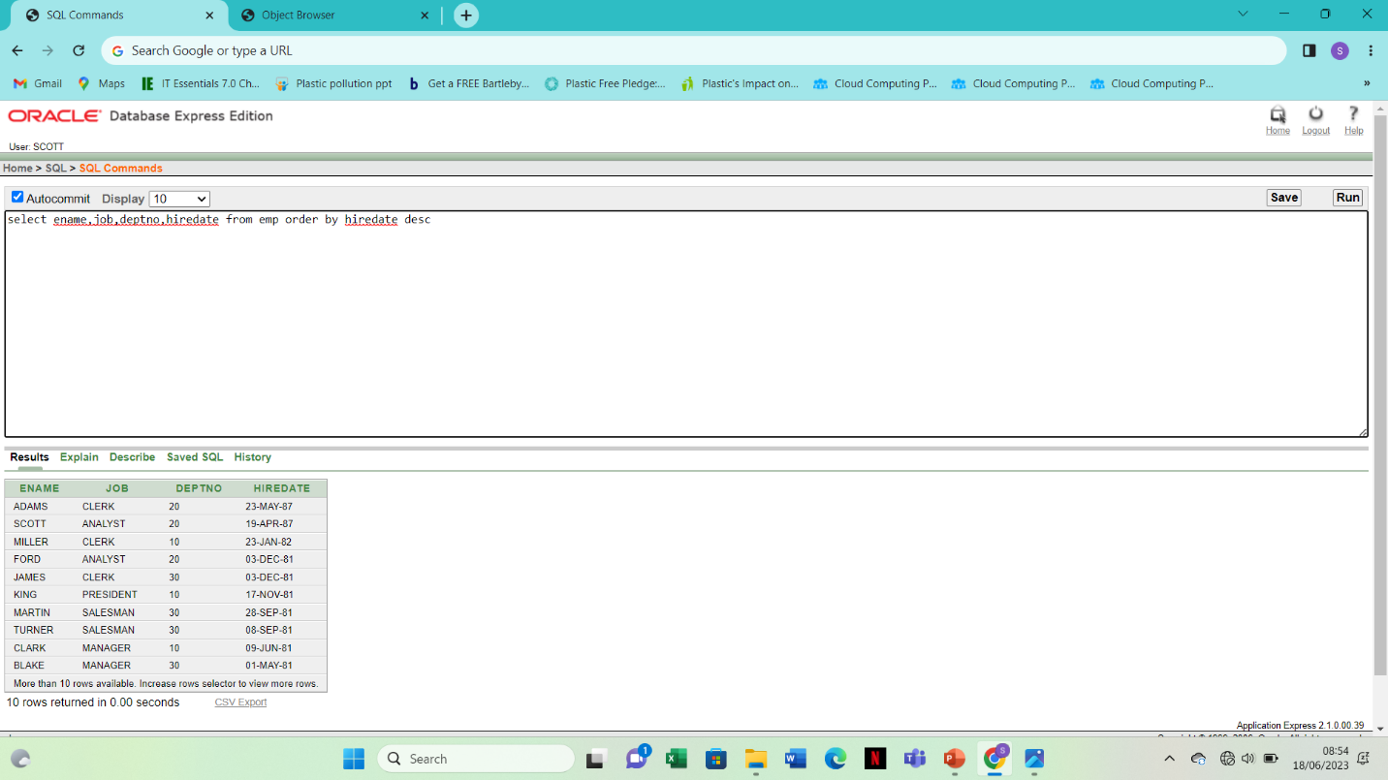

14.

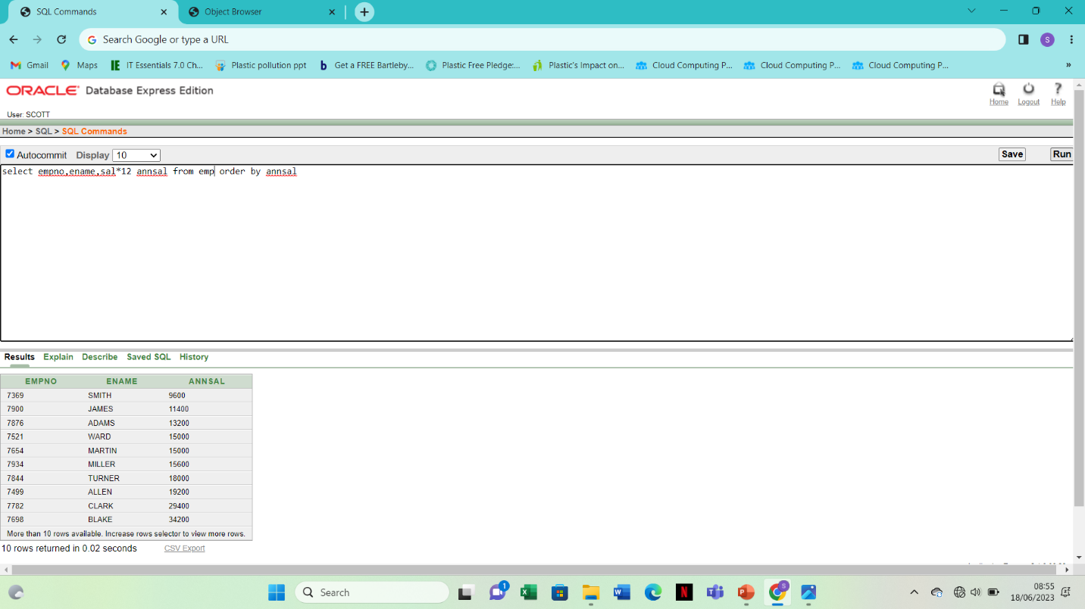

15.

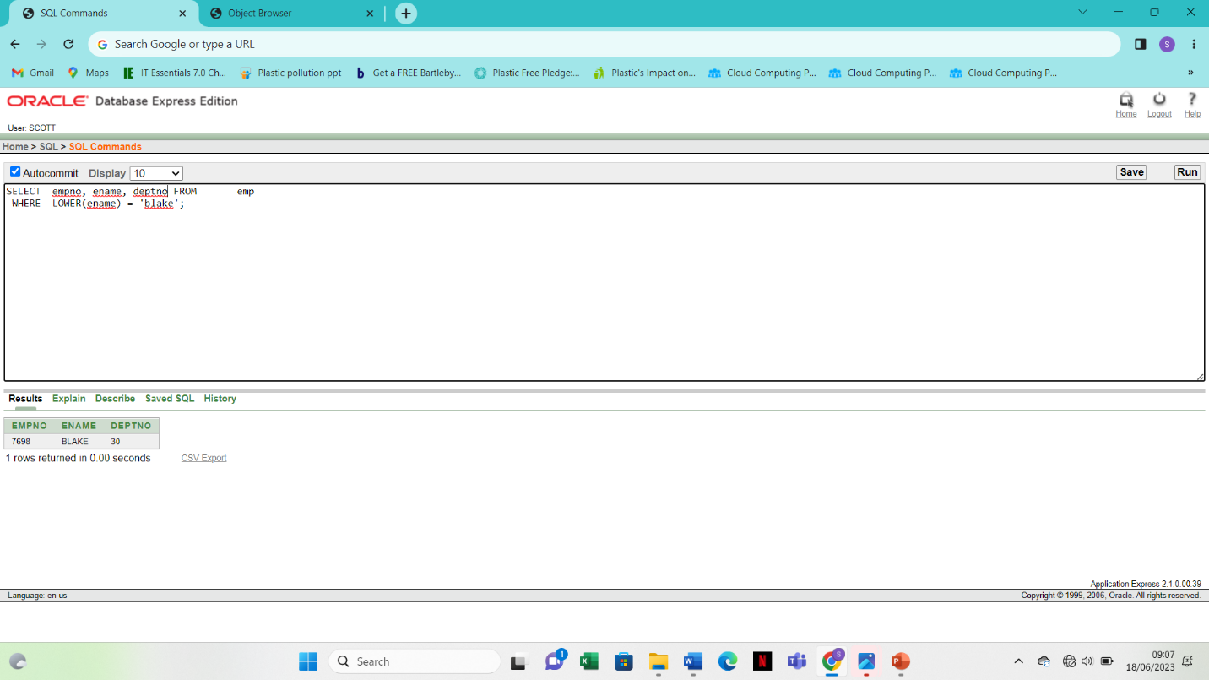

16.

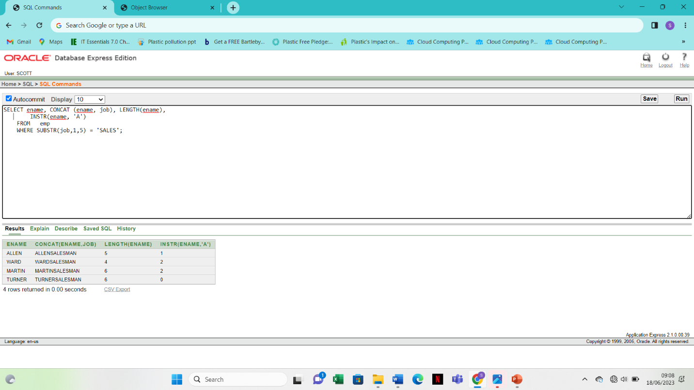

17.

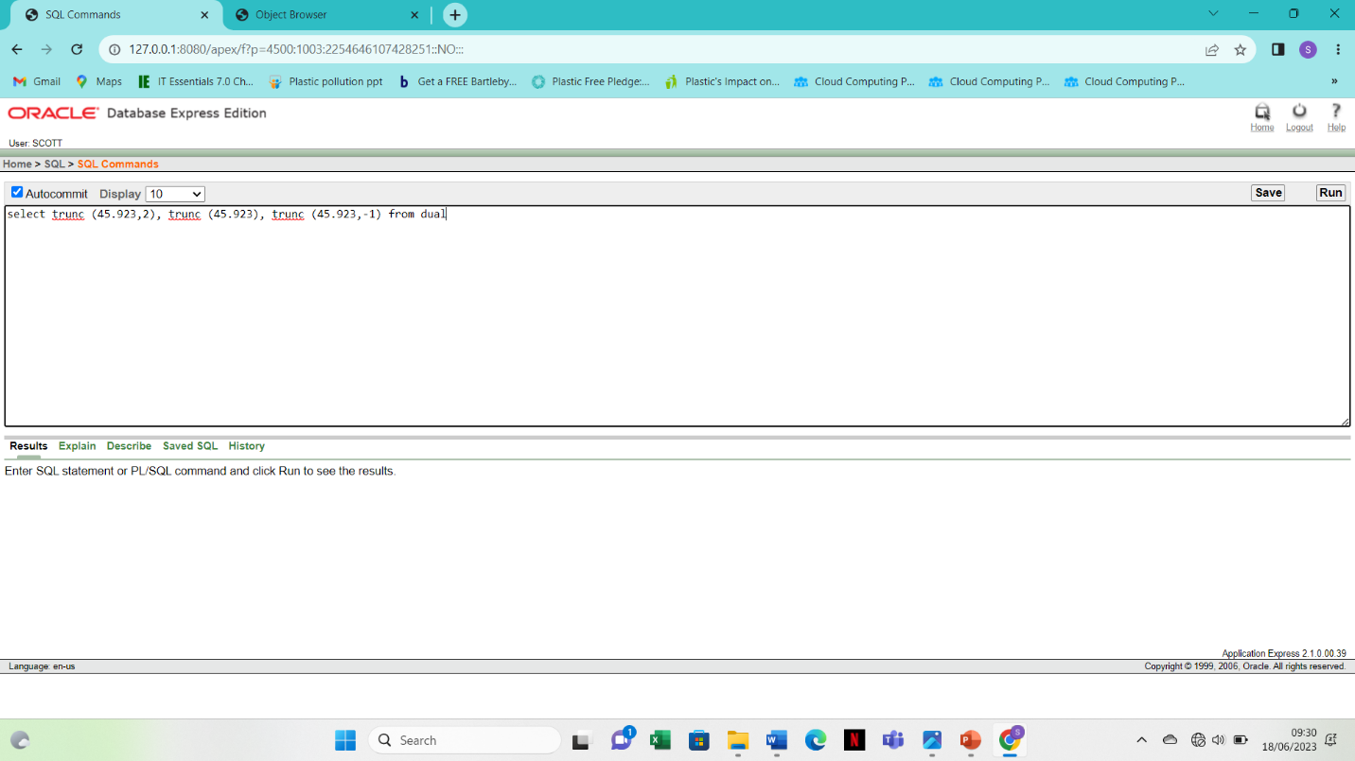

18.

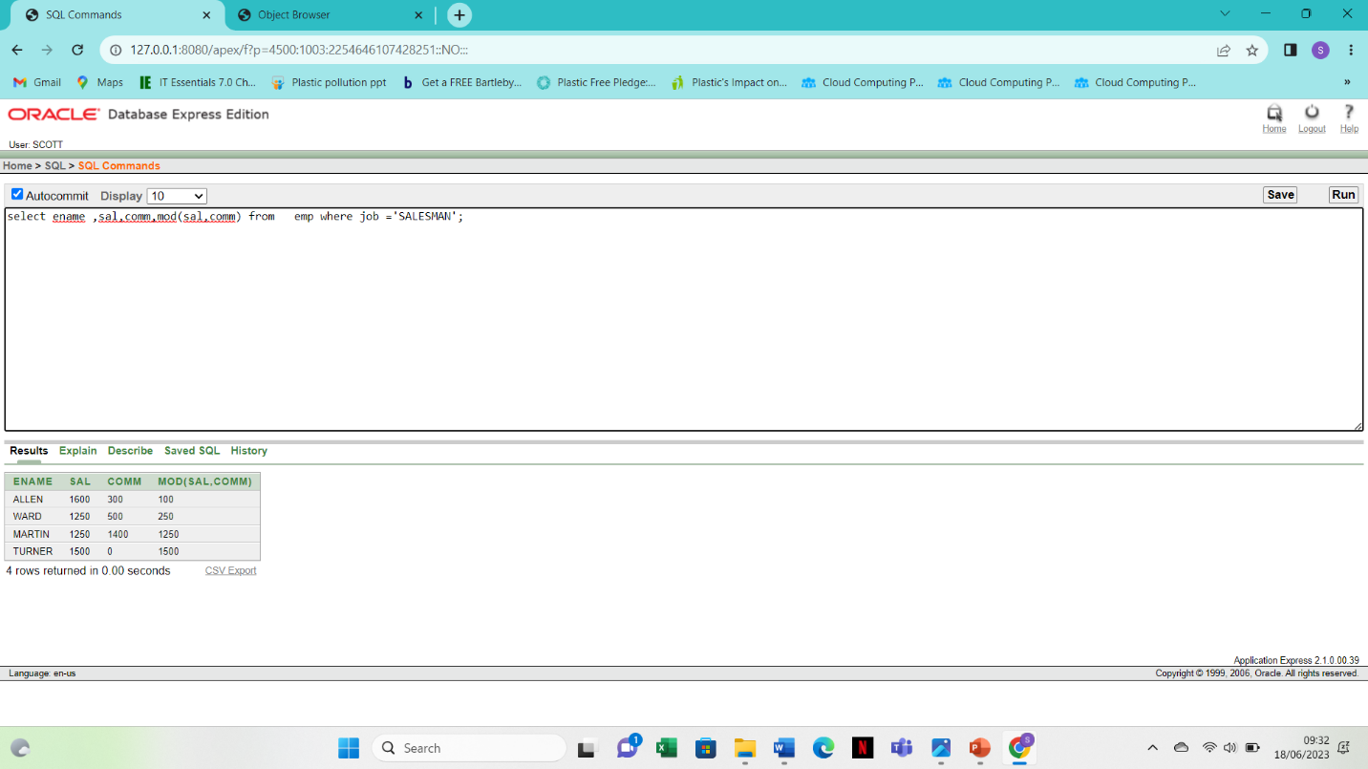

19.

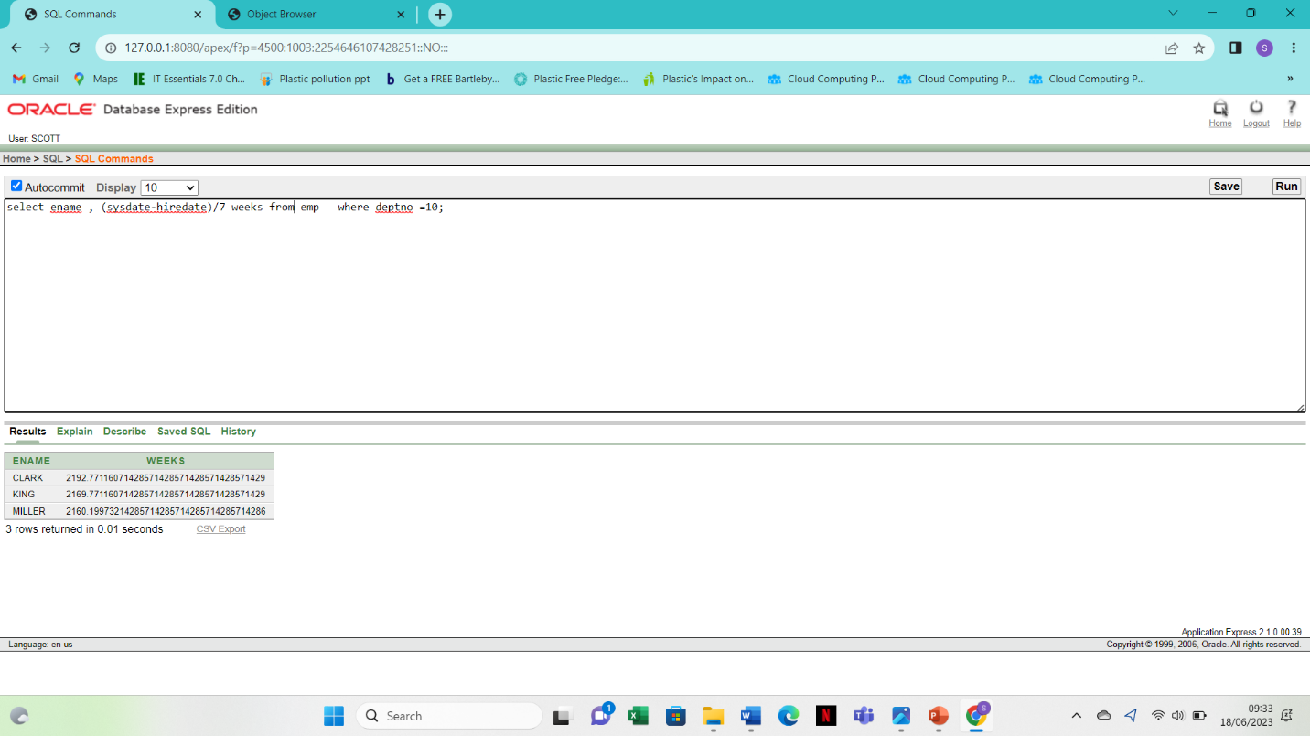

20.

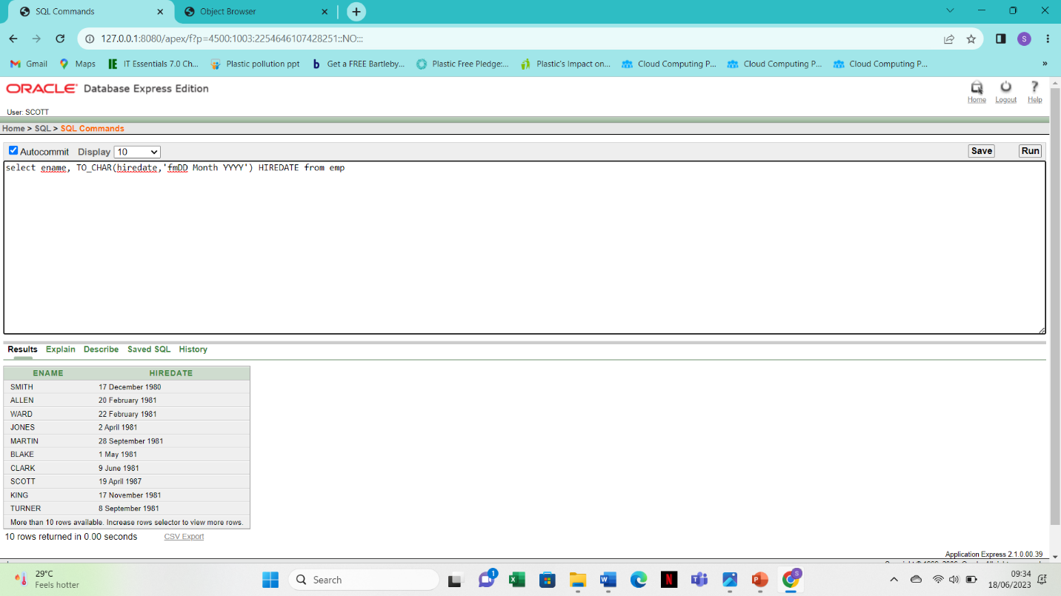

21.

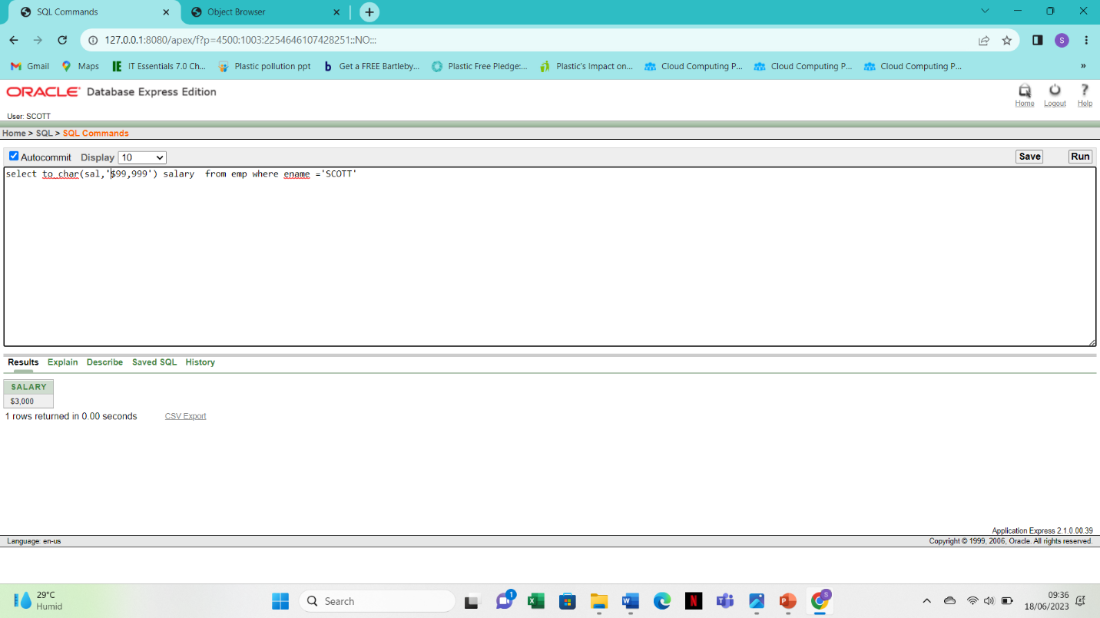

22.

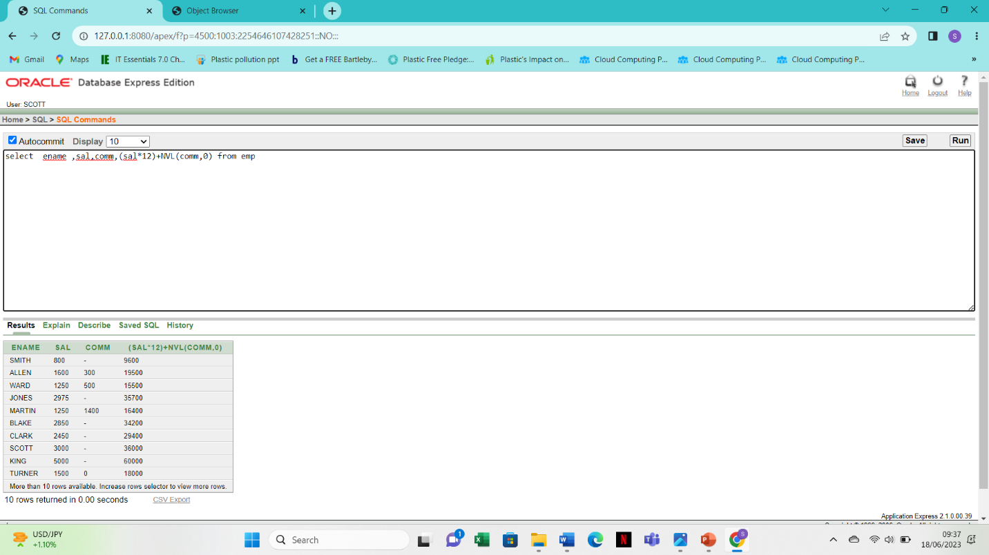23.

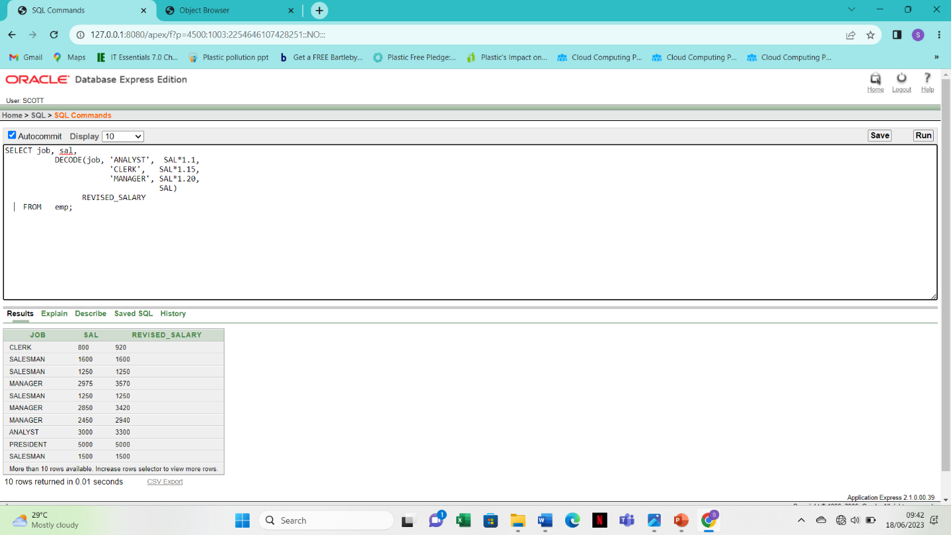

24.

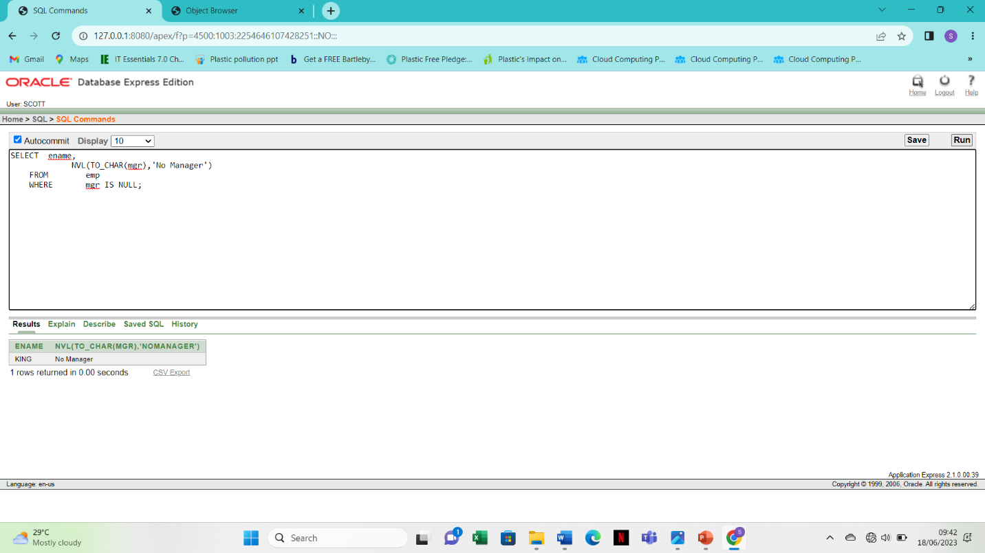

25.

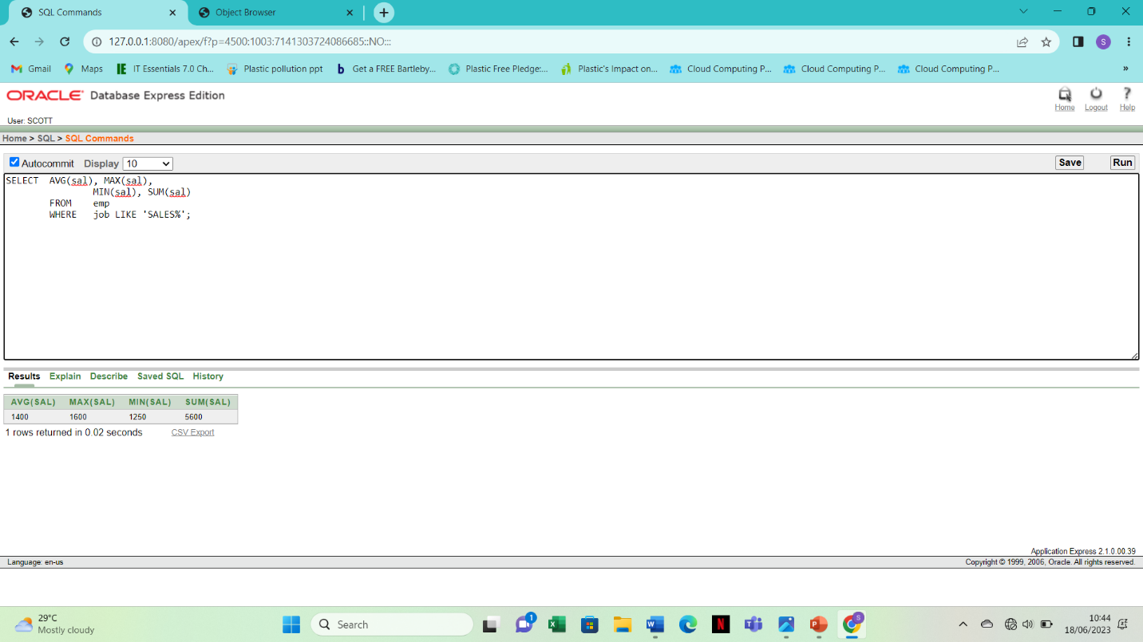

26.

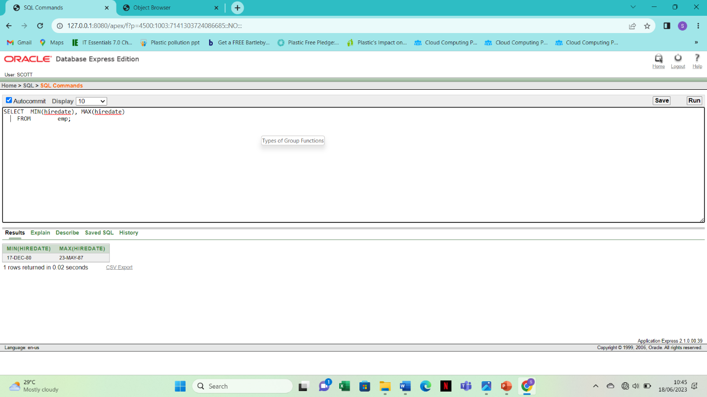

27.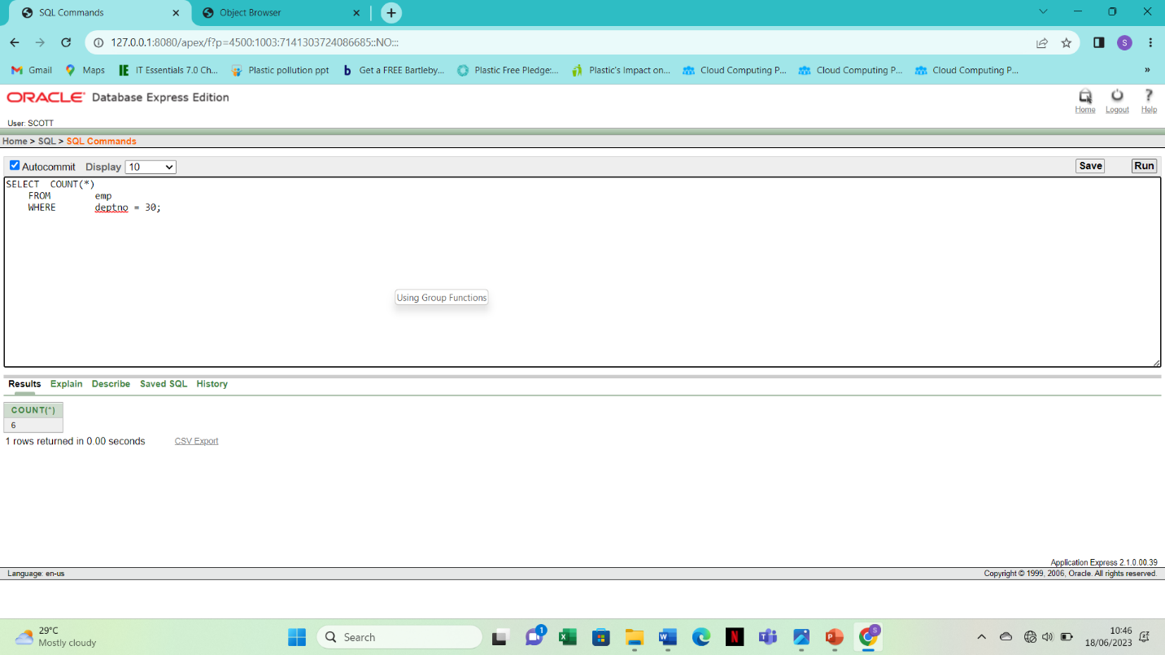

28.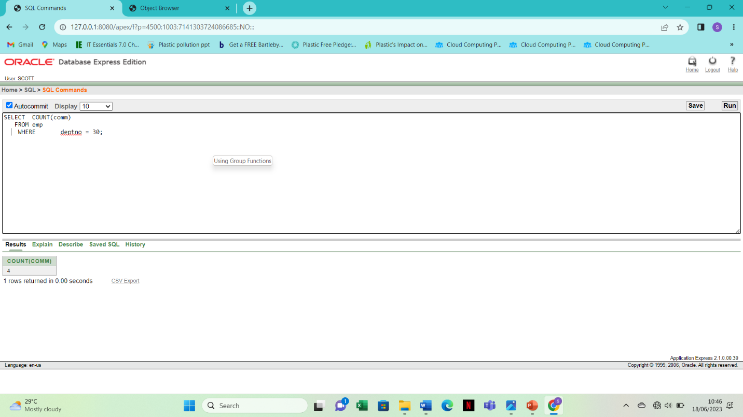

29. SELECT AVG(NVL(comm,0))

FROM emp;

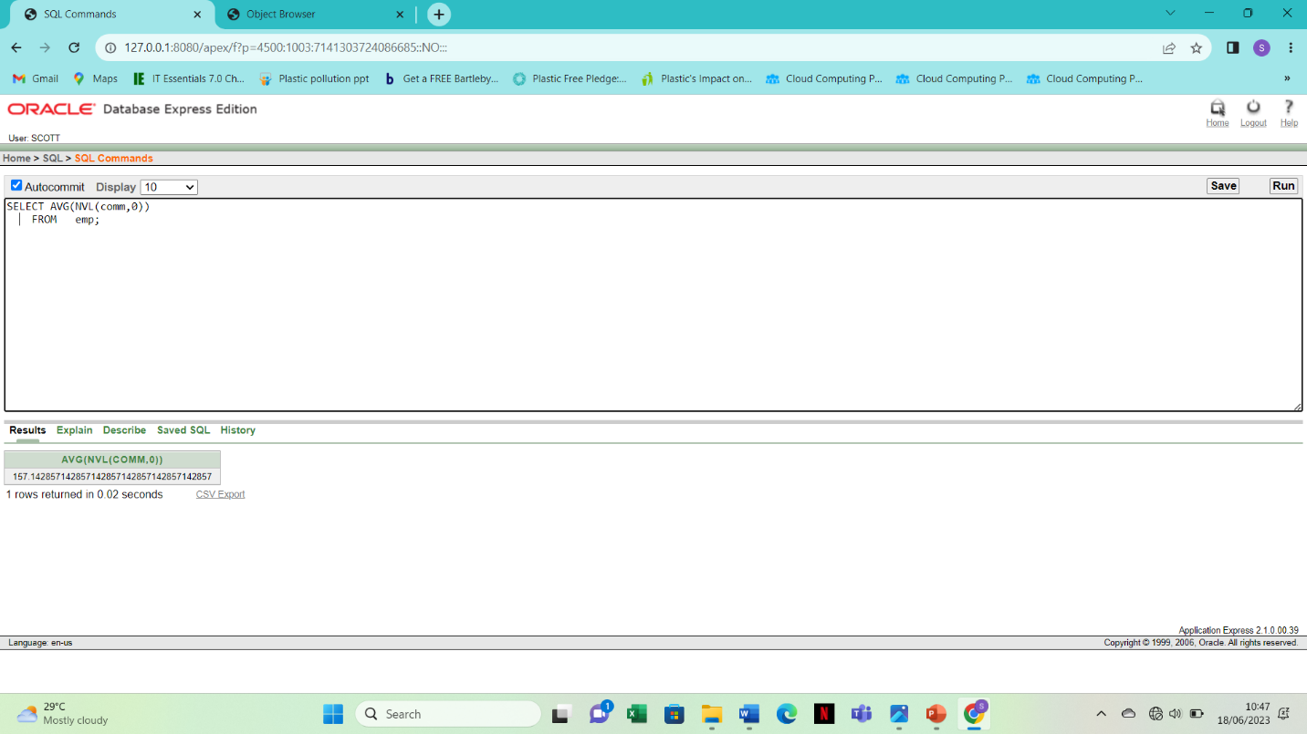

3. SELECT AVG(sal)

FROM emp

GROUP BY deptno;

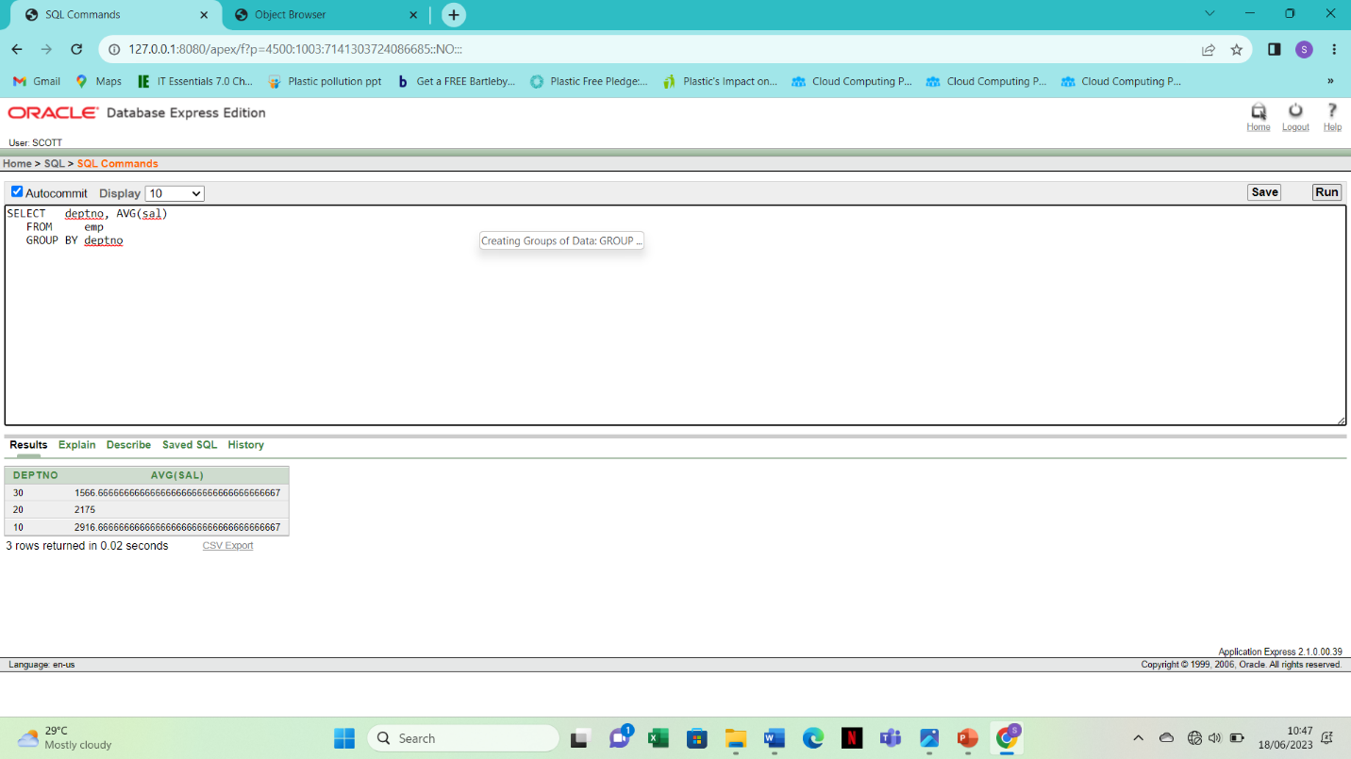

31. SELECT deptno, job, sum(sal)

FROM emp

GROUP BY deptno, job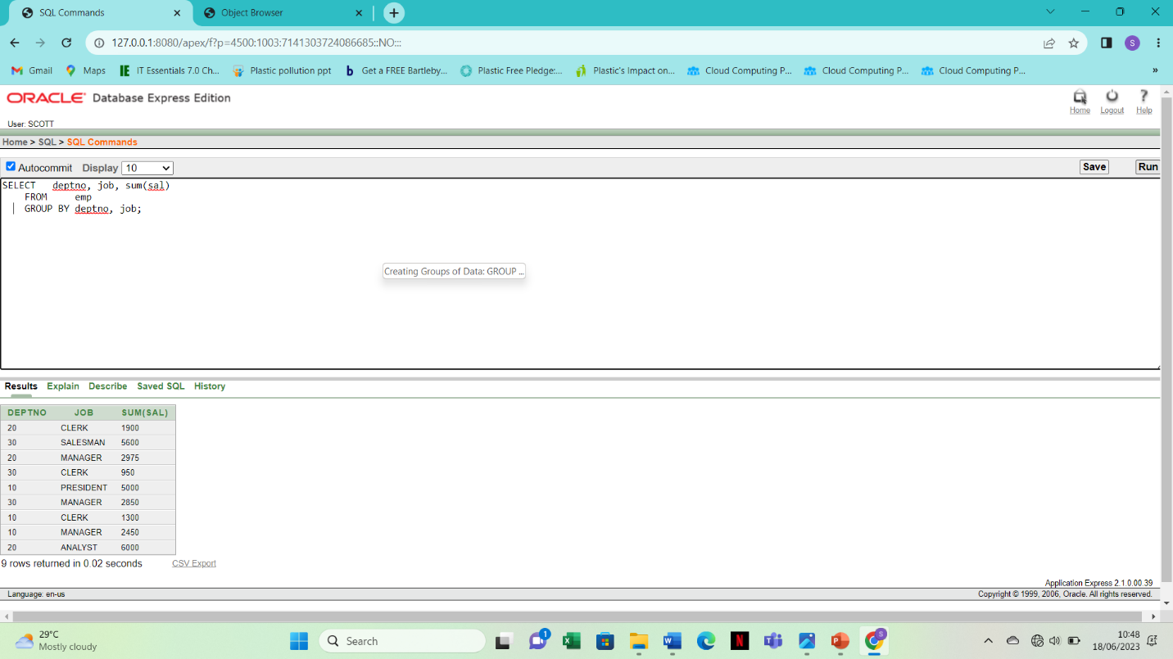

32. SELECT deptno, max(sal)

FROM emp

GROUP BY deptno

HAVING max(sal)>2900;

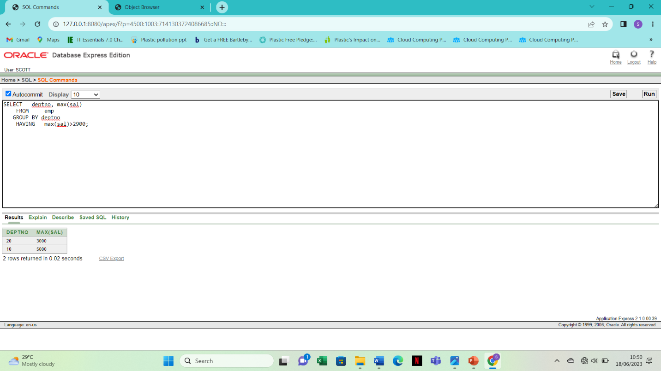

33. SELECT job, SUM(sal) PAYROLL

FROM emp

WHERE job NOT LIKE 'SALES%'

GROUP BY job

HAVING SUM(sal)>5000

ORDER BY SUM(sal);

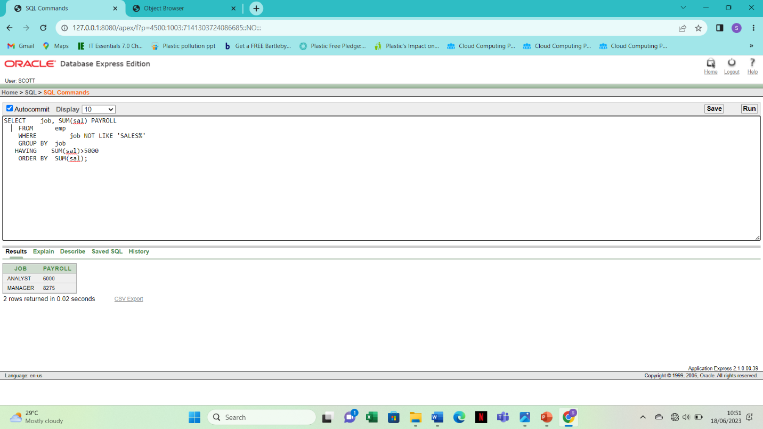

34. > SELECT max(avg(sal))

FROM emp

GROUP BY deptno;

